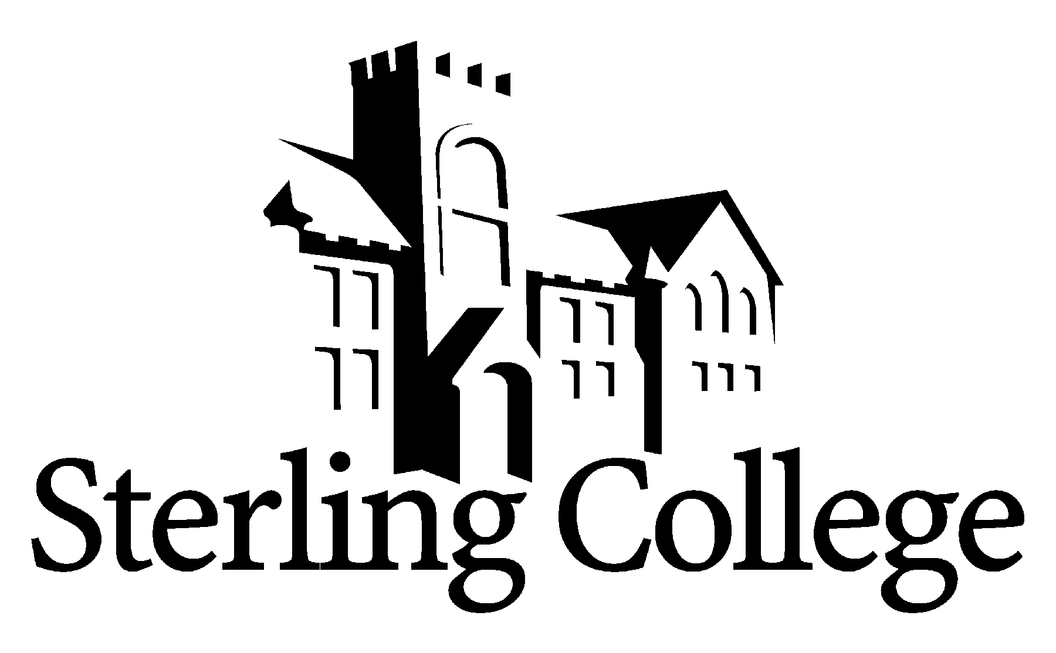
Faculty Position Announcement
Art & Design

POSITION
A full-time faculty position in the Department of Art & Design is available beginning August 1, 2017. We are seeking a broadly skilled individual to join a small, high-performing department. The ideal candidate would be primarily responsible for painting and drawing courses along with some foundations courses. Applicants who are energetic about holding high standards and developing high-caliber art students are encouraged to apply.

Applicants may view examples of recent current work in the online gallery:
www.sterling.edu/art/student-work

RESPONSIBILITIES
- Teach a variety of studio-based courses in the Department of Art & Design. Areas of instruction include painting, drawing, fine-art photography, and foundations (including art history courses, a philosophy of art course, and a professional development 1-credit course).
- As needed supervision of upper-level directed or independent studies including senior exhibition, assistance with gallery duties and recruiting of visiting artists.
- Additional responsibilities include the supervision of the spring-semester Juried Student Show along with the department Chair. The successful candidate will also be responsible for the curation, promotion and installation of the annual spring-semester student natural-media exhibit. Student workers, appropriate classes and other faculty may participate in the coordination and execution of both exhibits.
- To work with the Sterling Teacher Education Program and Art and Design faculty to maintain Kansas State Board of Education and NCATE/CAEP accreditation for Art Education students.
- Envision and promote program expansion and development including assisting with recruiting efforts in conjunction with the Department of Admissions and the Department Chair.
- Academically advise students within, or interested in, the Department of Art & Design.
- Adhere to departmental standards and hold student artists to a professional bar of excellence.
- As with all faculty members an intentional integration of Christian perspective within all aspects of the discipline, the advising of current students, the assisting in recruiting prospective students, and the participation in faculty committees.

QUALIFICATIONS
All SC employees are expected to demonstrate a strong and articulate Christian faith, to model and mentor students in servant leadership and in the integration of faith into life and learning. Specific requirements for this position include:
- M.A. required. M.F.A. preferred. Specific area of degree is not as important as portfolio, exhibition/publishing record, and references revealing an excellence of instruction.
- Active studio practice, exhibition experience and/or commercial application experience preferred.
- Strong collaborative skills and leadership ability.
- An understanding of an interdisciplinary approach to the liberal arts, and an ability to work with
faculty from diverse disciplines.
- College teaching experience that demonstrates an understanding of the teaching/learning process preferred.
- An understanding of undergraduate art students and an ability to relate well to them.
- Willingness to serve on faculty committees when asked.

COMPENSATION
Salary and rank will be determined by credentials and experience. The College provides a benefits package and a stipend for moving expenses.

THE COLLEGE
Founded in 1887, Sterling College’s mission is to develop creative and thoughtful leaders who understand a maturing Christian faith. With over 640 students and 46 full-time faculty members, the campus community shares a vision to be recognized as the finest Christ-centered, servant-leadership-development-focused liberal arts experience in the Great Plains. Located in Sterling, Kansas, the College enjoys a cordial relationship with this city of 2,600. Hutchinson (pop. 40,000) is a 25-minute drive, and Wichita (pop. 300,000) is about 65 minutes away. Learn more about us at www.sterling.edu.

APPLICATION PROCEDURE
A review of applications will begin immediately and continue until the position is filled. Women and minorities are encouraged to apply. The successful candidate must undergo a background check. To view the list of items to be completed to apply for this position, please go to https://www.sterling.edu/employment and view the Art & Design information. Materials are to be submitted electronically to rdodson@sterling.edu.

In addition to the online application, candidates must submit a 15 piece portfolio of their personal work in drawing and painting demonstrating a facility in representational and abstract/non-objective skills across oil and water-based mediums. Additional samples of photographic skill are welcome as well. Candidates are strongly encouraged to submit examples of student work created under their instruction.

Portfolios of still images, video reels or other media examples may be submitted as either a downloadable link, portfolio link, or medium-res JPGs. Attachments should be less than 15MB in total if emailed. Please do not send CDs or DVDs of portfolios for review. These items are also to be submitted electronically to rdodson@sterling.edu.

