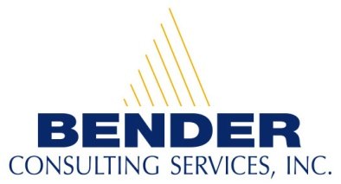
Recruiting and hiring people with disabilities for competitive career opportunities

Career Opportunities for People with Disabilities

Outreach Associate in Overland Park, KS

Contact Person: Sherry Homme
E-mail address: resume@benderconsult.com
Telephone Number: 412-446-4447
Fax: 412-787-7178

Qualifications:
- High school diploma or equivalent required. College degree or equivalent preferred.
- One year experience in healthcare or managed care industry, and some understanding of medical terminology. Experience in a health-related service such as community outreach worker, home health aide, ect. preferred.
- Must have a valid driver’s license.
- Must be able to speak English. Bilingual capabilities in Spanish or other language preferred.
- Proficiency in company-supported software (i.e. Excel, Outlook, Word).
- Must display good verbal and interpersonal skills, good telephonic skills, professional demeanor, appreciation of cultural diversity and sensitivity towards populations served, good organizational skills, and the ability to multi-task.
- Must be able to operate general office equipment including but not limited to: computer, phones, and related media and information devices.
- Must be able to travel independently as needed and adhere to Amerigroup travel policies and procedures.

Position Description:
- Provide members with information on how to access preventative and health maintenance services while identifying barriers to care.
- Arrange transportation for members as needed.
- Conduct telephonic outreach and/or home visits to facilitate preventative screenings and provide education to members utilizing approved resources and materials.
- Collect member encounter data and medical records, reviewing for completeness, and document member participation of activities as appropriate.
- Assist members in making appointments with his/her Primary Care Physician (PCP) and/or Specialist as indicated.
- Ensure members have seen their PCP and completed, or are in the process of completing, their treatment plan or preventive care services as advised.
- Assist members in identifying community resources, obtaining information related to classes and programs, and provide support for identified learning needs for the required level of care.
- Promote and support a professional relationship with providers and community resources by participating in community education events, health fairs, and clinic days as needed.
- Refer issues and concerns about members to the appropriate plan or corporate leader.

About our Company:
Bender Consulting Services, Inc. specializes in hiring individuals with disabilities for competitive employment opportunities. Positions include careers in information technology, finance, accounting, human resources, engineering, nursing, law, and other general business areas.
Our President and CEO, Joyce A. Bender, is the host of the international web-based talk show, Disability Matters with Joyce Bender. A person with epilepsy and a hearing loss, she has dedicated her life to furthering the employment and empowerment of people with disabilities. Ms. Bender received the New Freedom Initiative Award under the Bush Administration and the President’s Award from President Clinton. For more information, please visit our website at www.benderconsult.com.

3 PENN CENTER WEST - SUITE 223 PITTSBURGH, PA 15276
www.benderconsult.com
Competitive Jobs Mean Freedom

